EXPERIMENT- 28
Find the Boundary of the Image using Convolution Kernel for the Given Image
Aim
To write a Python code to detect the boundary of an image using convolution kernels in OpenCV for identifying object edges and boundaries.
Input Image
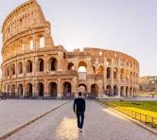
Code
import cv2
import numpy as np
from google.colab.patches import cv2_imshow
from google.colab import files
uploaded=files.upload()
image_path=list(uploaded.keys())[0]
image=cv2.imread(image_path,cv2.IMREAD_GRAYSCALE)
if image is None:
print("Error: Image not found")
else:
sobel_x=cv2.Sobel(image,cv2.CV_64F,1,0,ksize=3)
sobel_y=cv2.Sobel(image,cv2.CV_64F,0,1,ksize=3)
gradient=np.sqrt(sobel_x**2+sobel_y**2)
gradient=cv2.normalize(gradient,None,0,255,cv2.NORM_MINMAX)
gradient=np.uint8(gradient)
print("Boundary Image")
cv2_imshow(gradient)
Output Image
Boundary Detected Image
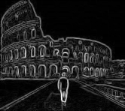
Result
Thus, the image boundary was successfully detected using convolution kernels in OpenCV.

